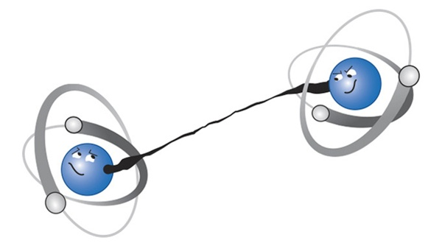

Happy Halloween, and try not to get too entangled with
spooky action at a distance before this Saturday!

