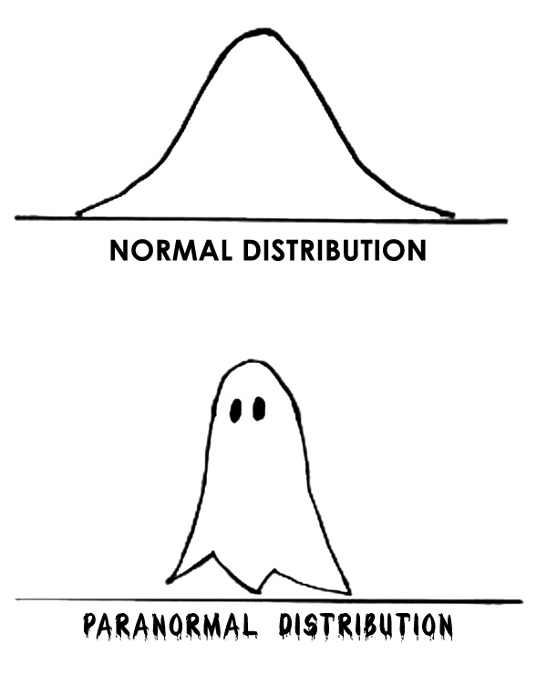

Happy Halloween, and get hyped for some spectral decomposition this Saturday!

